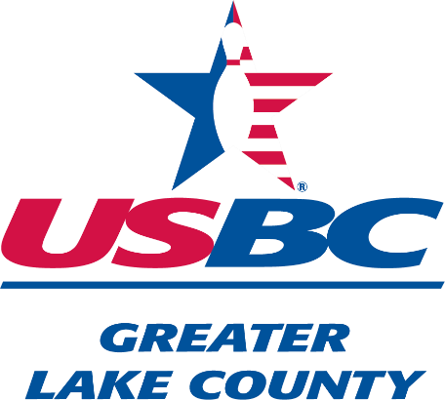
The purpose of the Hall of Fame is to honor and pay tribute to the people who have contributed to the growth and welfare of bowling by their ability and/or meritorious service to the Greater Lake County Bowling Association.

Qualifications for Nominations
A living candidate for the Hall of Fame must meet these requirements:

- Be a minimum of 45 years of age.
- Must have a minimum of 15 years as a certified bowler in any of the prior Lake County Associations, now known as the Greater Lake County Association.
- Must have bowled in at least 10 prior Lake County Association Championship tournaments, now known as the Greater Lake County Association.
- Have 15 years of service for the Meritorious award.

There are no age or certified requirements for posthumous nominees. Other qualifications that must be mentioned and explained are the proposed candidate’s character, leadership, dedication, and other bowling achievements. Consideration will be given towards Lake County Championship titles, honor scores and Bowler of the Year achievements.

HALL OF FAME NOMINATION APPLICATION

Nominee’s Name:

Nominee’s Address:

Nominee’s Date of Birth: ______________ Birthplace:

Nominee Award Status: Living Posthumous:

Nominee Award Category: Meritorious Superior

Nominee’s years in USBC:

Years in certified leagues in Lake County Associations (LCBA/LCWBA/WWBA):

Number of Championship tournaments bowled in Lake County Associations:

Background and/or characteristics of nominee (what are/were they like):
__________________________________________________________________________________

__________________________________________________________________________________

__________________________________________________________________________________

__________________________________________________________________________________

General Comments (If nominee is posthumous, use this space for date of death and name(s) of survivors.):
__________________________________________________________________________________

__________________________________________________________________________________

__________________________________________________________________________________

__________________________________________________________________________________

Achievements of nominee (any Lake County Association’s Championships, honor scores and other achievements):
__________________________________________________________________________________

__________________________________________________________________________________

__________________________________________________________________________________

__________________________________________________________________________________

Nominator Information Name:

Address:

City, State and Zip: Email:

Signature of Nominator: Date:

All applications must be postmarked or received by March 1, to be considered for the current year. Please print or type all information to make sure it is legible.

All submitted forms will be kept on file for five years for future considerations. All information is subject to verification.

The Hall of Fame Committee reserves the right to accept or reject any nomination.

Please contact the Hall of Fame Committee Chairperson if there are any questions.

Sue Hallwas
GLCUSBC Hall of Fame
702 Ridgewood Cir.
Antioch, IL 60002-3112
Email: jghallwas@aol.com

2023_hof_nomination_revised_04-23eb

